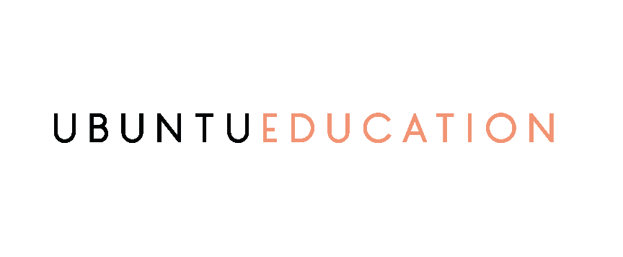

Deliverables:

- Grow the company’s social media community on Facebook, Instagram, and LinkedIn
- Achieve a minimum of 100 to 150 new conversions per month
- Build engagement with existing community members by responding to their messages, comments, and sending them direct messages
- Develop message templates, FAQ, and automated responses for the 3 different templates
- Send emails to the mailing list
- Attend to inquiries and post comments on the 3 social media platforms
- Create and fill a weekly report for the required tasks

Admin tasks
- Develop questionnaires and forms for TA when needed
- Create messages for TA on social media platforms and email
- Handle required admin work to perform the social media growth and course enrolment deliverable

COMPENSATION

For Services rendered under this Agreement, the Company will pay Consultant $ 1000 for the full delivery of the services mentioned above.
In addition, the company will pay the consultant 1% bonus on the total increase in yearly sales

Payment terms:
100% Upon receiving and approving the full deliverable
Bonus is paid at the end of the first quarter of the following year

